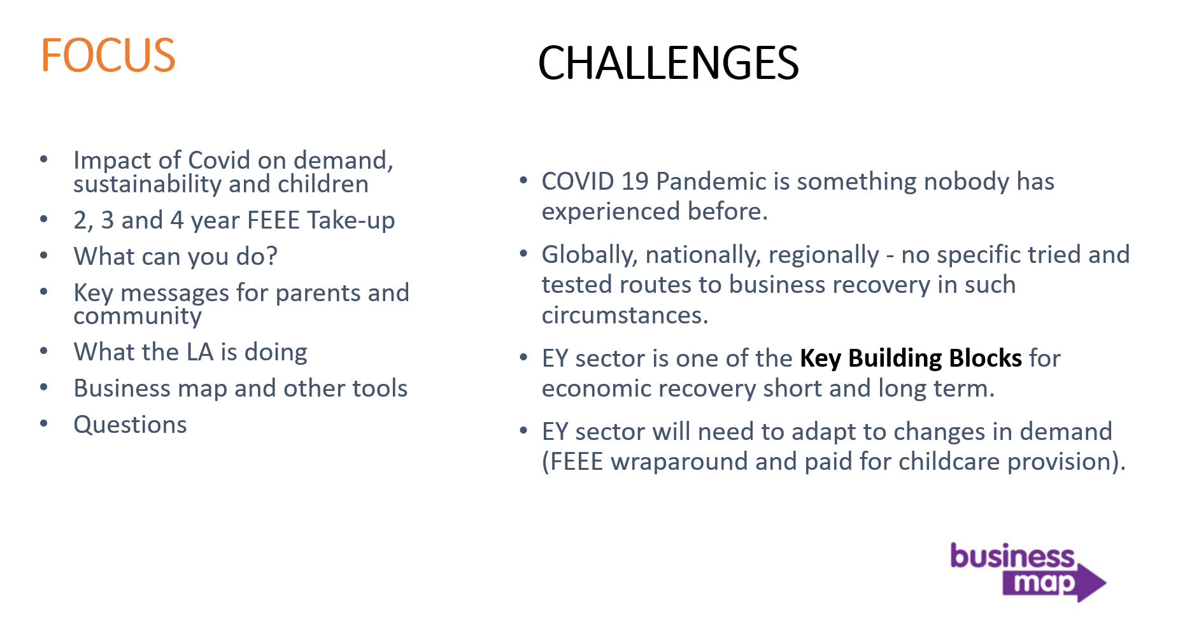
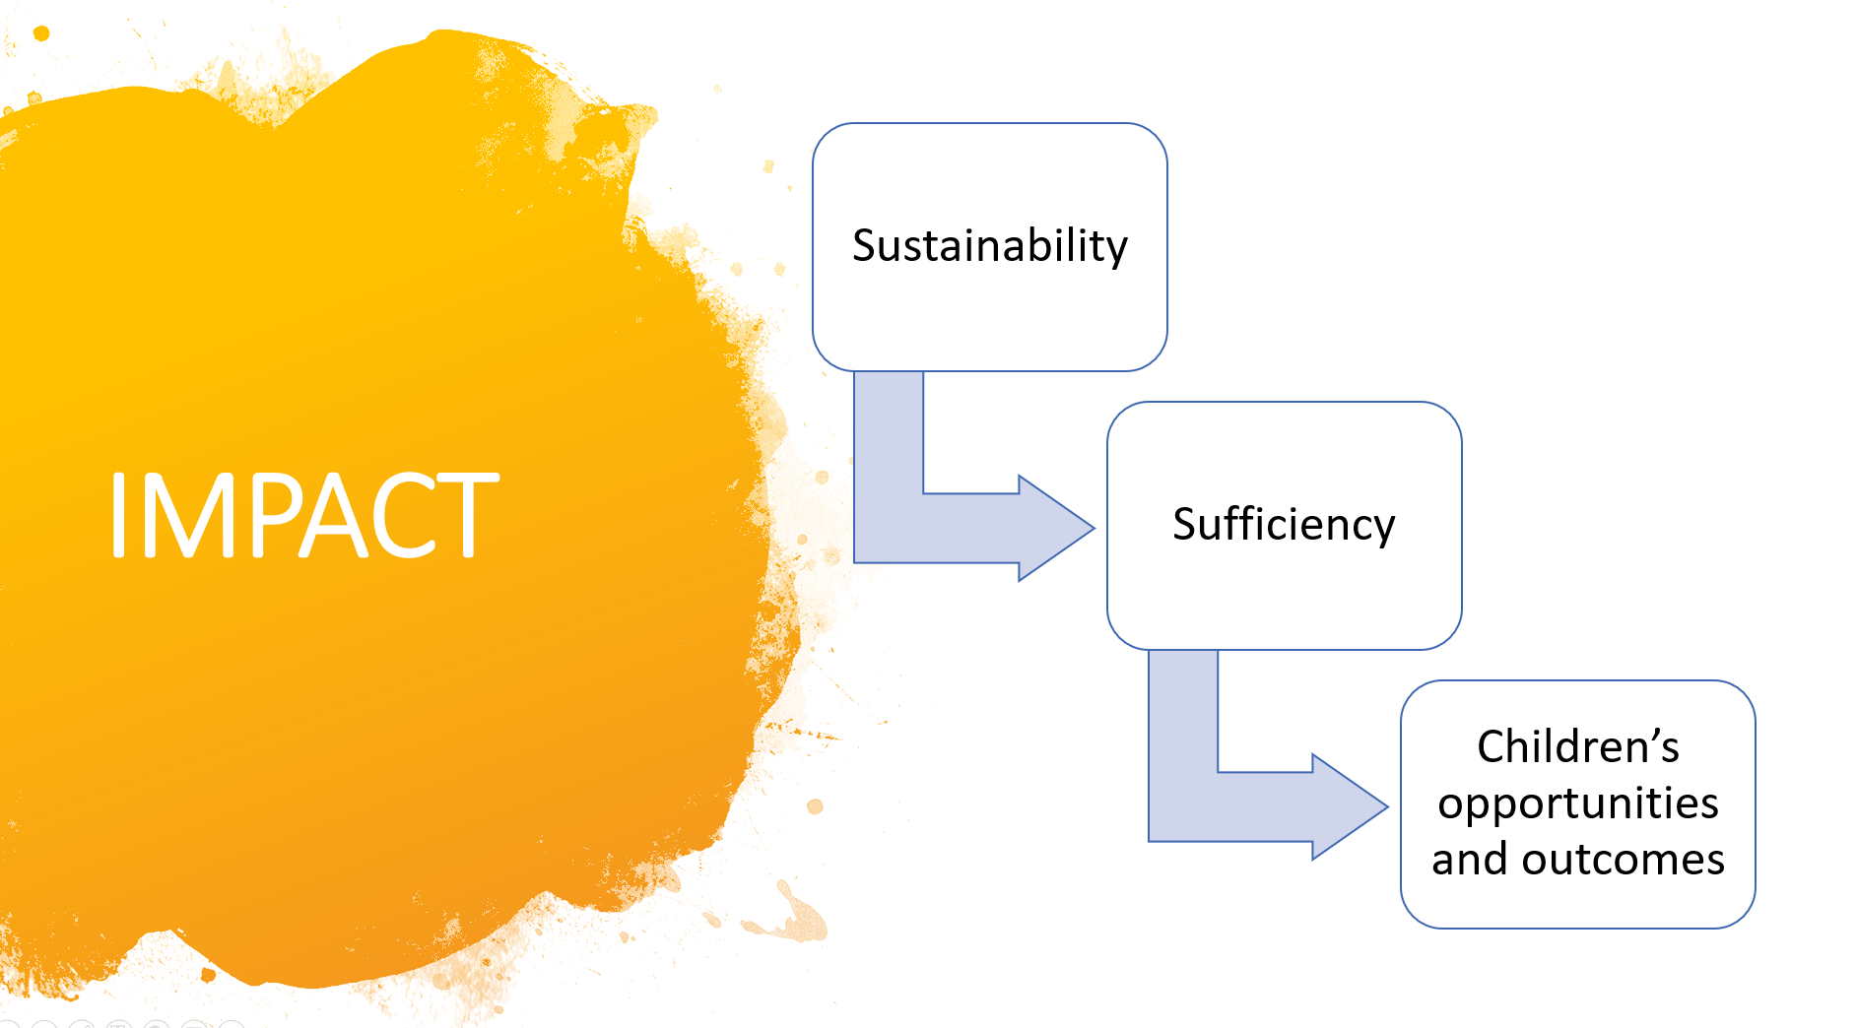
The Covid-19 pandemic is having an adverse impact on:
- Sustainability of providers:
The take-up of services, especially wrap around and out of school care, has declined sharply and the costs of delivery have increased as providers are having to implement Covid-safe practices.
- Sufficiency of places:
Sustainability issues will result in loss of capacity due to closures or providers having to scale back their services e.g. range, flexibility, hours of operation, staffing and overall capacity to help them operate in a Covid-safe way.
- Children’s opportunities and outcomes:
Due to the extended lock-down the earlier restrictions to access, the numbers of early years children accessing provision regularly or at all has been very low and this will have impacted on their learning outcomes.

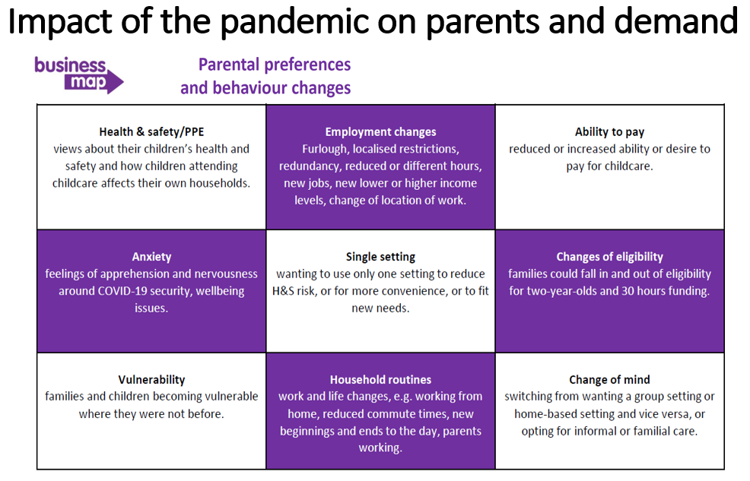

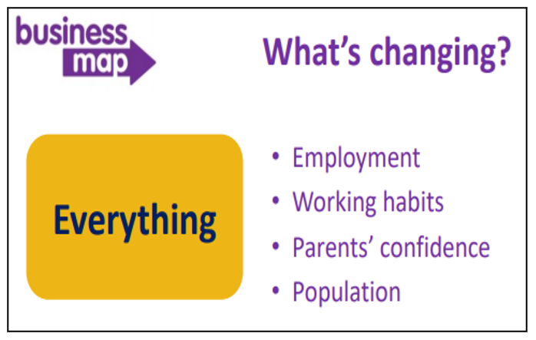

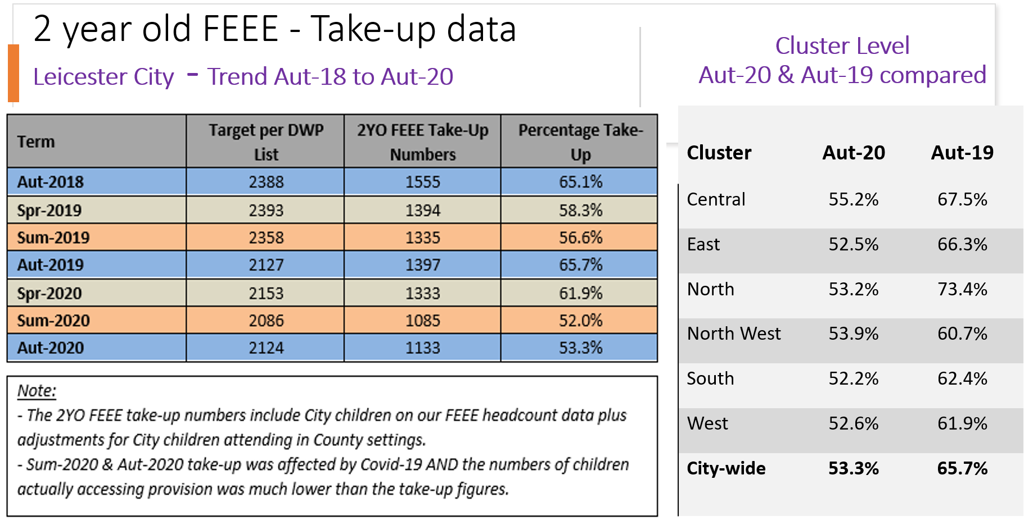
- The target numbers are from DWP lists of parents, who are potentially eligible for 2YO funding, which are made available to the LA for each term. The target numbers have been declining mainly because the economic criteria for eligibility has remained static whilst the National Living Wage/Minimum Wage rates have increased each year.
- The percentage take-up in Leicester has remained lower compared to some regional or similar LA areas.
- The Covid-19 pandemic has an unprecedented effect on take-up and attendance in Sum-2020 and Aut-2020.
There is opportunity for providers to increase their 2YO FEEE numbers as the data shows that quite large numbers of eligible 2YOs are not accessing their entitlement each term.
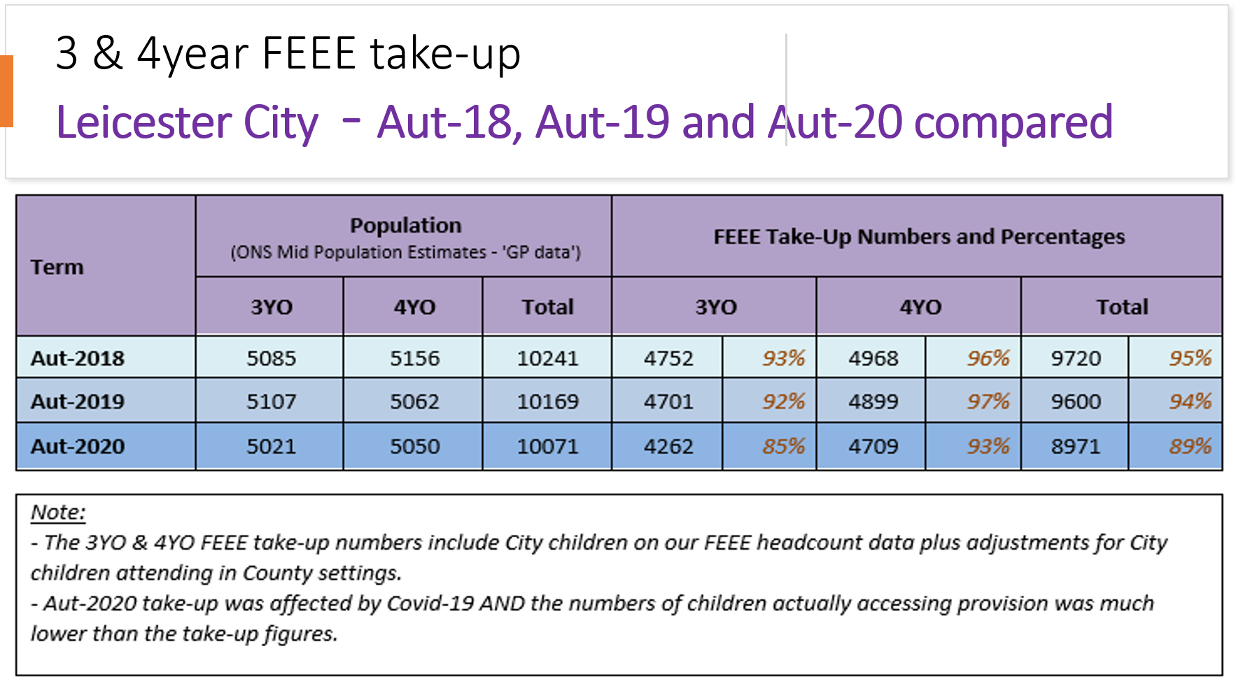
- The population trend for 3- & 4-year olds indicates there is a small decline in numbers from one year to the next.
- The Covid-19 pandemic has an unprecedented effect on take-up and attendance in Aut-2020.

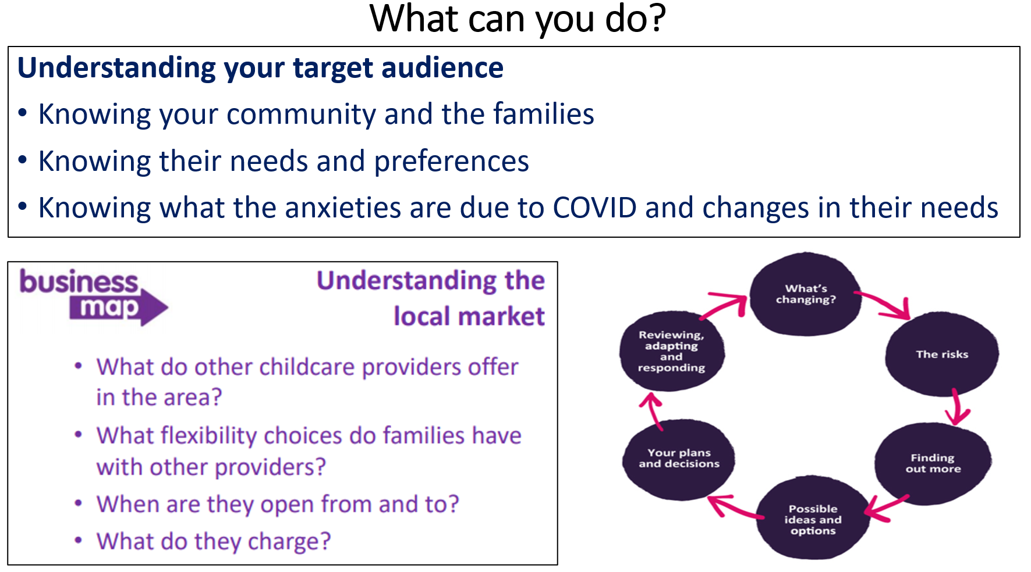

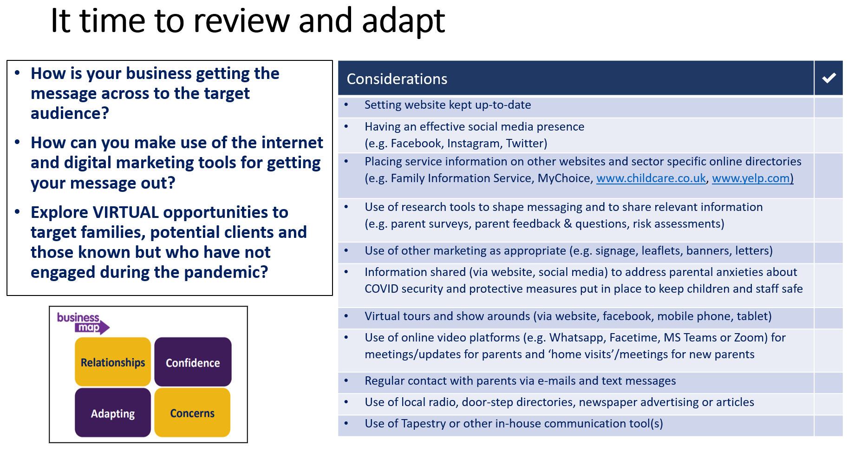

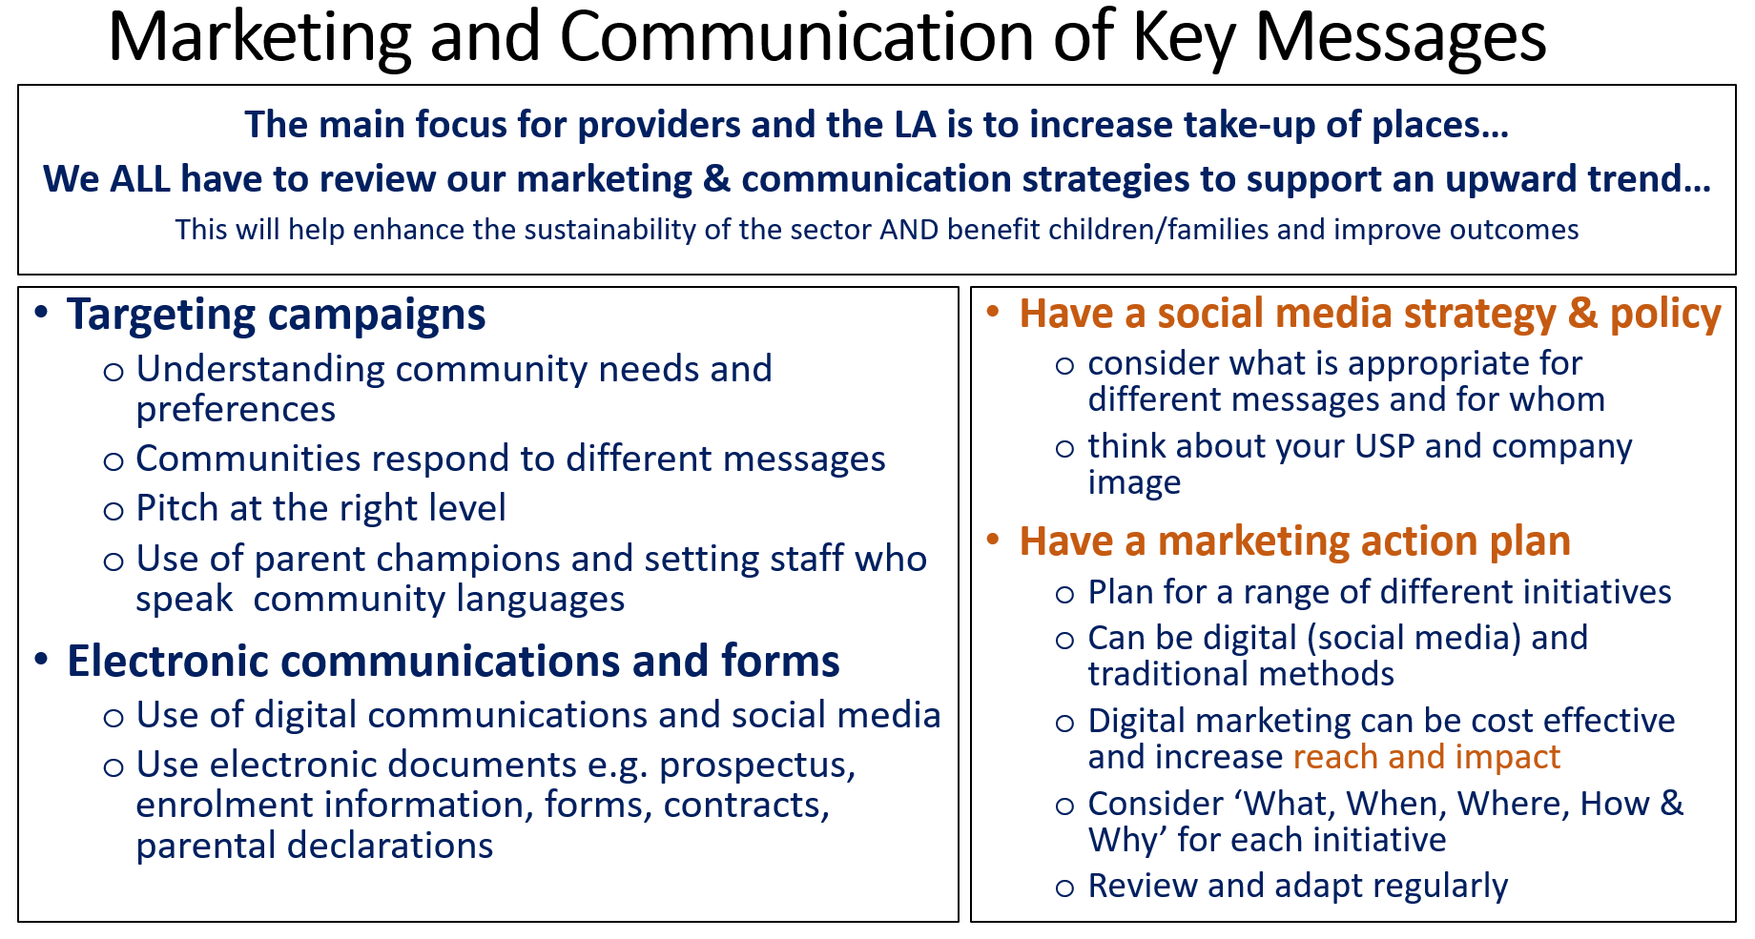

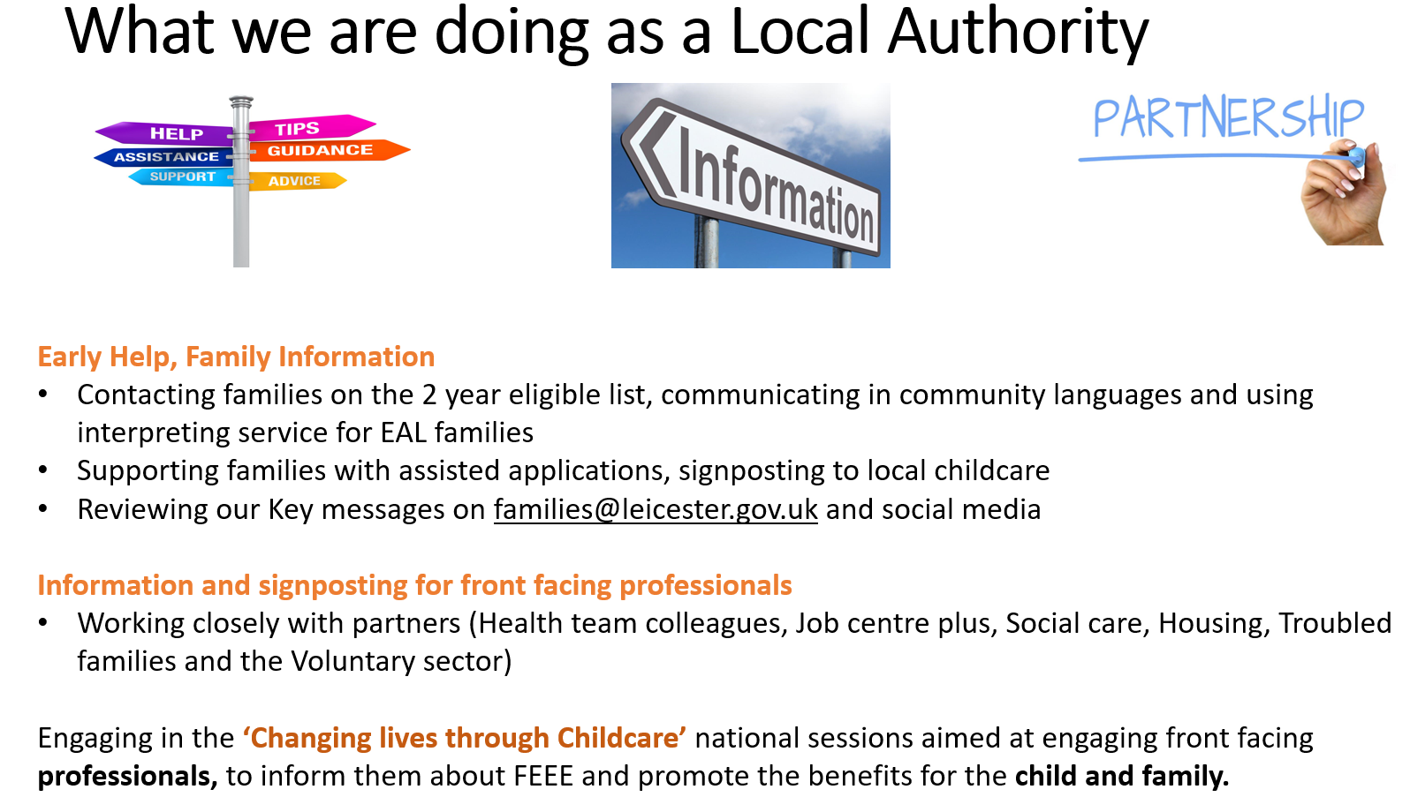

Business map and other tools

Hempsall’s Business Map for early years providers:
- https://foundationyears.org.uk/2021/01/hempsalls-business-map-for-early-years-providers/

Other tools:

LA Business support - tools and tips (COVID-19)
- https://families.leicester.gov.uk/childcare-professionals/coronavirus-updated-advice/business-support-tools-and-tips-covid-19/

From PACEY:
- https://www.pacey.org.uk/working-in-childcare/spotlight-on/2-year-olds/the-2-year-old-offer/
- https://www.pacey.org.uk/Pacey/media/Website-files/PACEY%20general/EAL-Checklist.pdf

Changing live through childcare (professionals briefing)
- Access the slides and a paper here: https://foundationyears.org.uk/2021/02/hempsalls-changing-lives-through-childcare-webinar/
- Access the recorded webinar here: https://youtu.be/c5_6m82NHZo

Early Education Development Team support

If you would like more information or would like to discuss your business sustainability or ideas for marketing then please request a support by complete the Business support questionnaire (E-form) via: https://families.leicester.gov.uk/childcare-professionals/data-collections/business-support-questionnaire/

